BURNS (nee Balks), Denise
Year of ’59
26/6/1942 – 29/2/2012

OBITUARY

Denise Balks was a NGHS Prefect in the 1959 Leaving year, who then studied languages in an Arts degree at Newcastle University and went on to teach German and English at high schools.

Denise was a quiet, gentle, pretty lady who married Malcolm Burns and became a devoted wife and mother of three lovely children.

After Malcolm’s tragic, accidental death in USA, Denise resumed her studying of the German language, through which she met a nice group of fellow enthusiasts and enjoyed a number of trips with them to Germany. Denise was also a very gracious and generous host to annual Burns family weekends at Minnamurra.

As a close school friend of Denise, I was very fortunate to become a close relative as I married Malcolm’s brother, Bruce.

Sadly, Denise died from cancer on 29/2/2012. I miss her dearly.

Carole Burns (nee Sharman), NGHS School Captain 1959

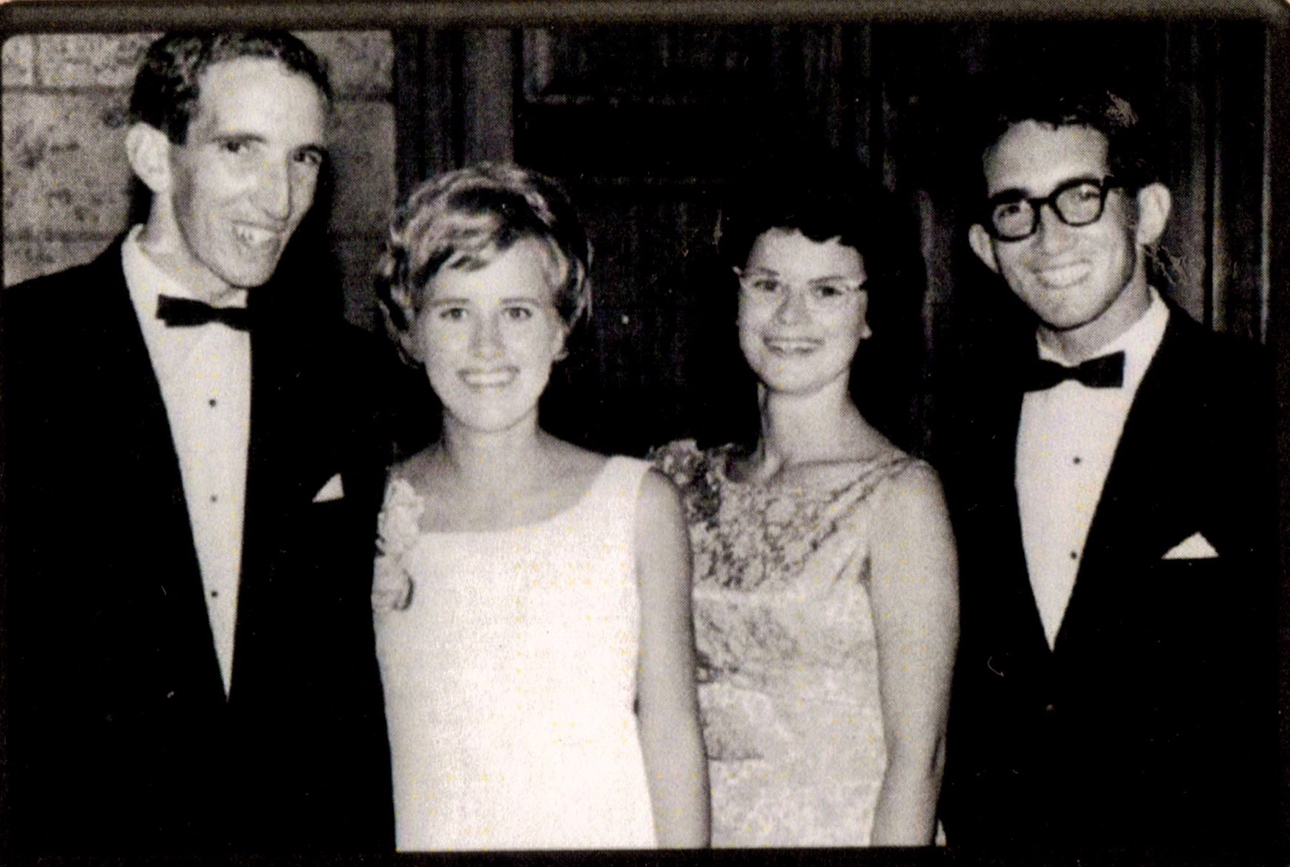
L-R. Malcolm Burns, Denise Burns nee Balks, Carole Burns nee Sharman, Bruce Burns.

